

[**Alfa Cleaning Systems**](javascript:void(0);)

[Bhandup West, Mumbai, Maharashtra](https://www.google.co.in/maps/dir/19.148455,72.92757)

GST :**27AAOFA7537Q2ZK**

# About us :

Established in 2006, Alfa Cleaning Systems is amongst the leading trader and wholesaler of Pressure Machine, Pressure Hose, etc. We also provide Cleaning Service and Waterproofing Service to our clients. Our offered range of products and services are rendered by a highly skilled team of professionals by keeping in mind the modern market developments. These products and services are highly applauded for affordability and timely execution.

We have an efficient crew which consists of professional experts and experienced quality auditors who work judiciously to attain maximum customer satisfaction. We offer training to our team members on a regular basis to improve their skills and capabilities. Under the vigilance of Mr. PADMAKAR NIMBALKAR (Partner), we have attained a strong foothold within the domain. We have a capacious and a hygienic warehouse unit wherein we store our products securely.

# Why Us?

With the assistance of rich vendor base, we are able to meet the requirements of our customers within the promised time period. Some of the other factors that attract the customers towards us are as follows:

* State-of-the-art infrastructure
* Diligent team
* Affordable prices
* Ethical business practices
* Timely deliveries

# Products and Services

## **Water Storage Tanks Cleaning Service:**

### **C:\Users\Dinesh\Downloads\IMG-20190402-WA0001.jpg**

### **Settling Tank Cleaning Services:**

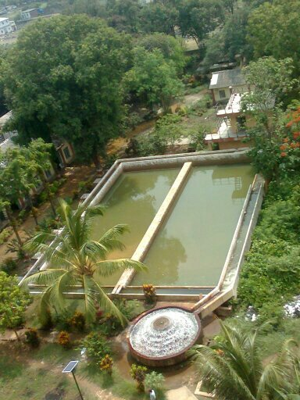

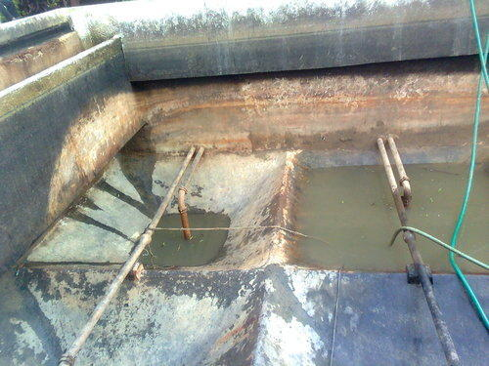

**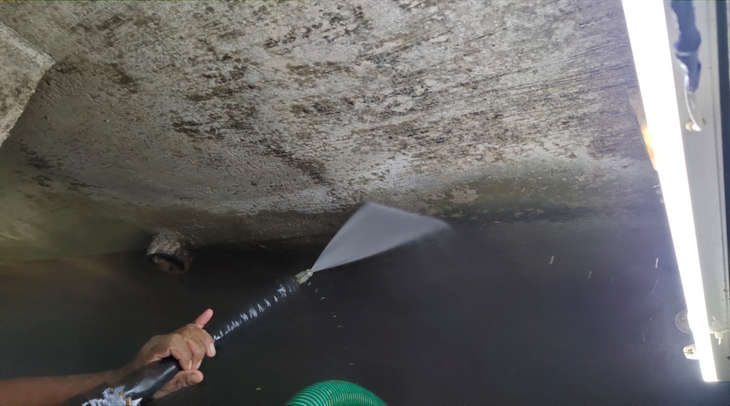**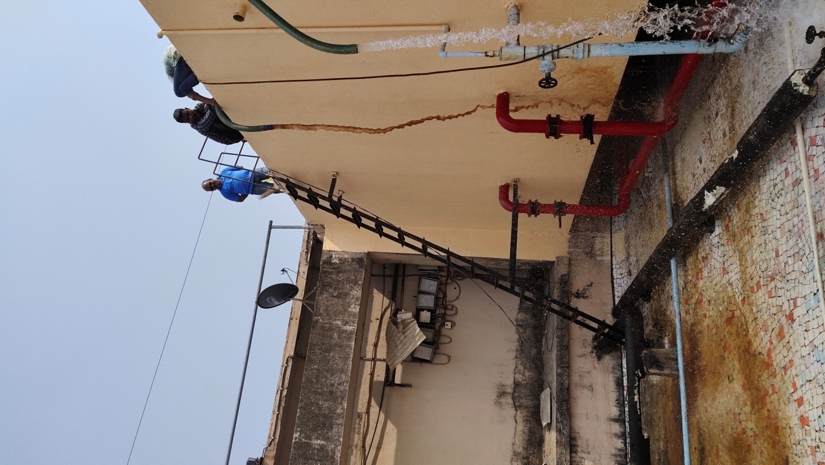**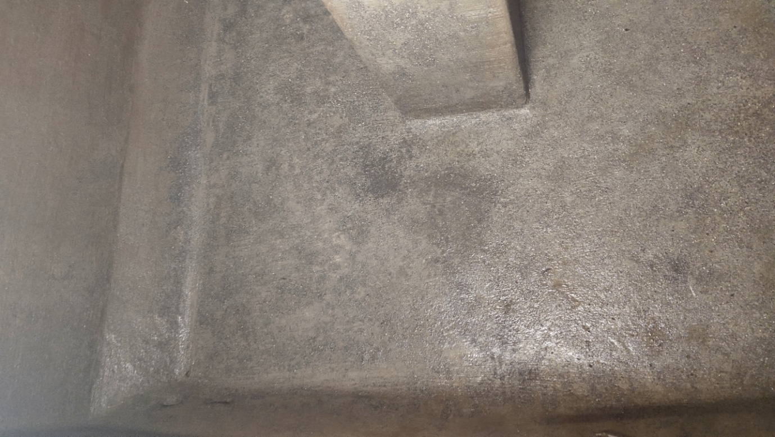**

### **D:\alfa Clng\alfa docum PHOTO\IMG_20210726_173211.jpg**

### **Plastic Water Storage Tank Cleaning Services:**

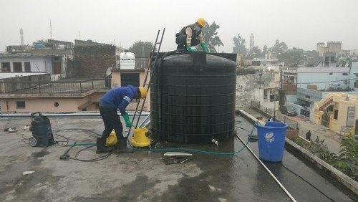

### **Big Overhead and underground tank cleaning services:**

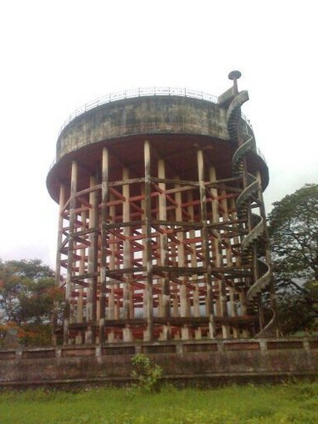

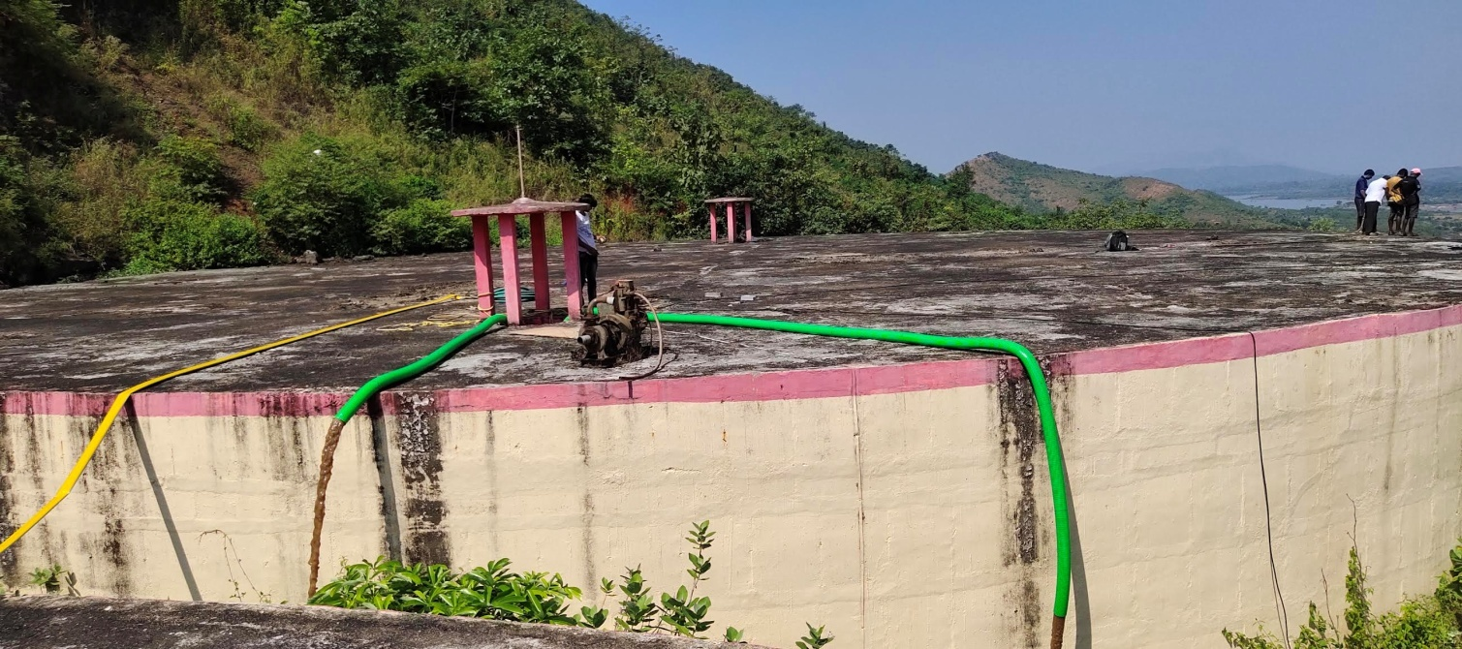

## **Floor cleaning Services:**

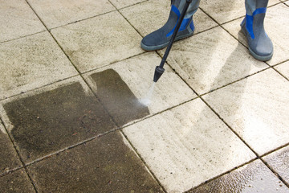

## **Open Well Cleaning Services:**

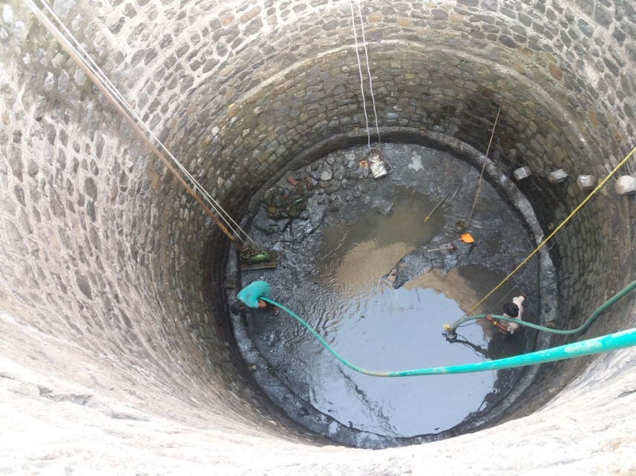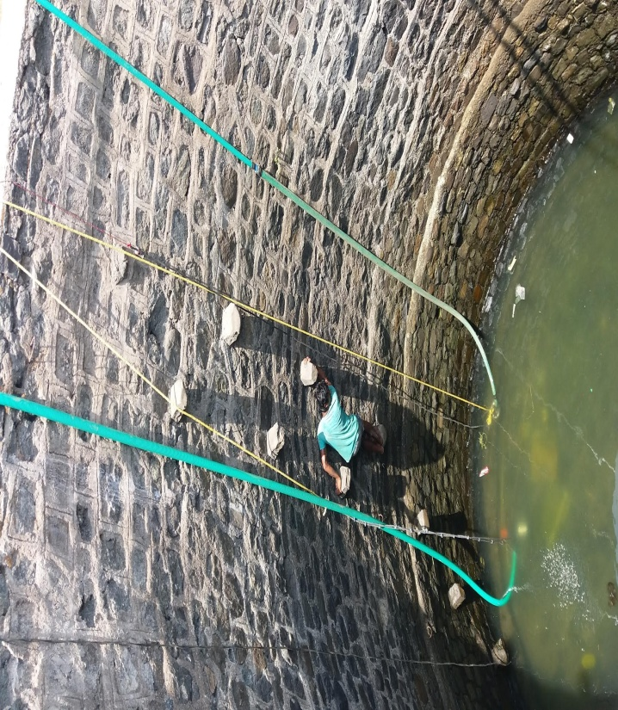

## **Building Terrace Cleaning Services**

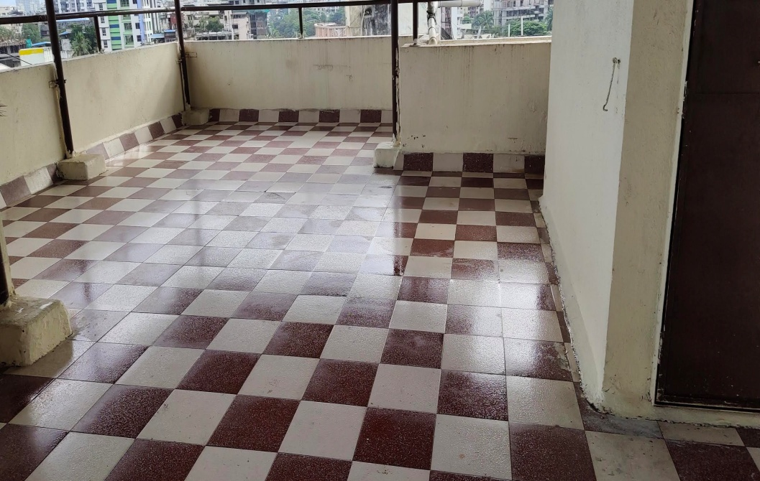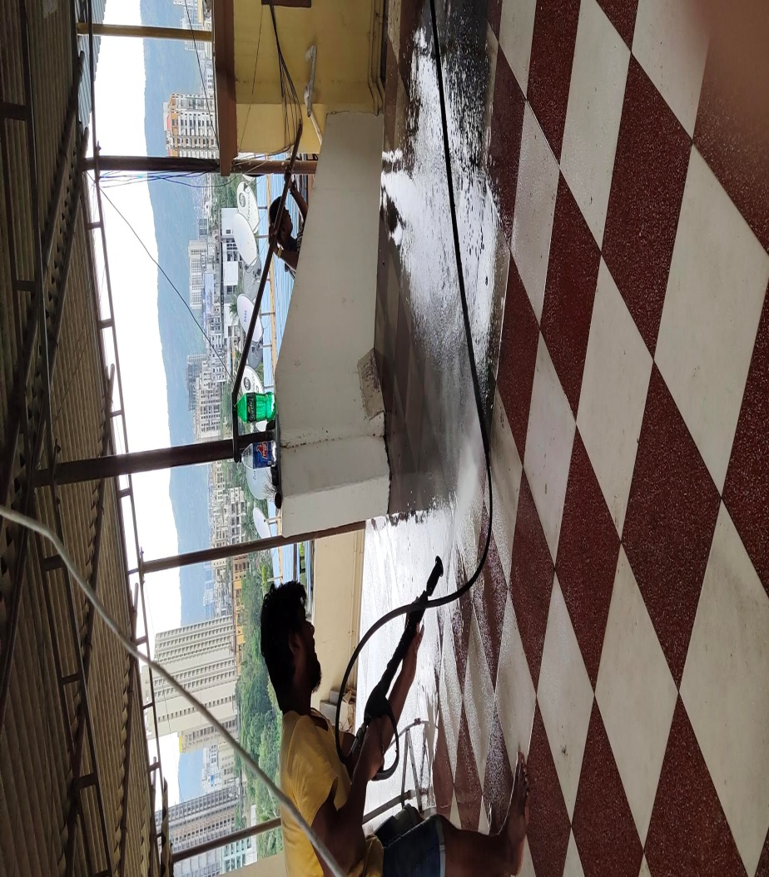

# Process:

We implement 3 stage of tank cleaning process:

* **Stage I – De-Watering:**

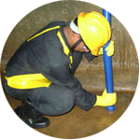

Water is pumped out of the tanks using an electrical pump.

* **Stage II – Access lid cleaning:**

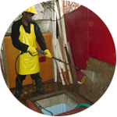

The access lid and its immediate surroundings are cleaned off mud, algae, dirt etc. using a high pressure washer.

* **Stage III - Sludge Removal:**

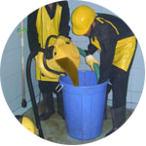

Sludge, mud and dirty water are removed using a sludge pump and a wet vacuum cleaner.

# Safety Measures:

Following are the main risk factorsconsidered while cleaning a water tank.

## **Height**

Safety equipment like Safety shoes, helmets and ladders are used to avoid accidents while working from elevated places.

## **Safety Equipment used**

Gumboots, Safety shoes, Helmets, Harness, Rope ladder, safety glares.

# List of our valued clients:

## Major Clients:

***LIST OF OUR VALUED CLINETS***

|  |  |
| --- | --- |
| ***NAME OF PARTY*** | ***LOCATION*** |

|  |  |  |
| --- | --- | --- |
|  | ***VASAI-VIRAR CITY CORPORATION***  ***WATER TANK & SATALINK TANK*** | ***VIRAR, NALASOPARA,***  ***VASI, NAIGOAN,*** |
|  | ***RESERVE BANK OF INDIA*** | ***MUMBAI*** |
|  | ***HINDUSTAN PETROLEUM CORPORATION LTD.*** | ***MUMBAI*** |
|  | ***UM-DAE CEBS KALINA MUMBAI UNIVERSITY*** | ***KALINA SANTACURZ*** |
|  | ***T.S.CHANAKYA(INDIAN MARITME UNIVERSITY Navi Mumabi*** | ***NAVI MUMBAI*** |
|  | ***BHARAT PETROLEUM CORPORATION LTD.*** | ***MUMBAI*** |
|  | ***WESTERN RAILWAY*** | ***MUMBAI*** |
|  | ***KALINA UNIVERSITY , SANTACRUZ MUMBAI`*** | ***MUMBAI*** |
|  | ***UNION BANK OF INDIA*** | ***MUMBAI AND , NAVI MAUMBAI*** |
|  | ***BANK OF INDIA*** | ***MUMBAI, NAVI MUMBAI*** |
|  | ***CENTRAL BANK OF INDIA*** | ***CBD BELAPUR , NAVI MUMABI*** |
|  | ***JASLOK HOSPITAL*** | ***GRANT ROAD*** |
|  | ***STATE BANK OF HYDRABAD*** | ***GOKULDHAM*** |
|  | ***H.S.B.C. BANK*** | ***MUMBAI*** |
|  | ***ORIENTAL INSURANCE CO. LTD.,*** | ***CHURCHGATE*** |
|  | ***PASSPORT OFFICE (MANISH COM.CENT)*** | ***PRABHADEVI DADAR*** |
|  | ***SIEMENCE INDIA LIMITED*** | ***WORLI, KHARGAR*** |
|  | ***COLGATE HOUSE*** | ***POWAI*** |
|  | ***L & T LTD MHAPE*** | ***MHAPE NEW MUMBAI*** |
|  | ***J.S.W. LTD., BKC*** | ***BKC BANDRA*** |
|  | ***VOLVO INDIA LTD.,*** | ***PELHAR*** |
|  | ***FREE PRESS HOUSE*** | ***NARIMAN POINT*** |
|  | ***INTERNATIONAL INDUSTRIAL SPRING*** | ***THANE*** |
|  | ***JN PETIT LIBERRY (D.N. ROAD)*** | ***FORT*** |
|  | ***OMKAR REALTORS & DEVELOPERS P.LTD*** | ***SION OFFICE*** |
|  | ***BHOLENATH DEVELOPERS PVT. LTD.*** | ***CHEMBUR*** |
|  | ***RUSTOMJEE BUILDER LTD.(GLOBLE CITY)*** | ***VIRAR, MUMBAI*** |
|  | ***RUNWAL & OMKR ESQUAR PREMISES*** | ***SION*** |
|  | ***FORBES & COMPANY LTD.*** | ***FORT MUMBAI*** |
|  | ***VOLCART HOUSE LTD*** | ***BEACH CANDY HOSPT.*** |
|  | ***BABAJI SHIVRAM CO.*** | ***SAKINAKA NAKA*** |
|  | ***EDOC SOLUTION P.L. Transmission Hs.*** | ***MAROL MIDC ANDHERI (E)*** |
|  | ***HDC INDIA PVT. LTD*** | ***SEWRI*** |
|  | ***INDUSTRY HOUSE LTD., (BIRLA HOUSE)*** | ***CHURCHGATE*** |
|  | ***CENTURY PARK (BIRLA RESIDENCE)*** | ***PRABHADEVI*** |
|  | ***AVARSEKAR & KEJRIWAL CONST. LTD.*** | ***WORLI*** |
|  | ***PENINSULA FACILITY LTD.*** | ***MUMBAI*** |
|  | ***SWASTIK CHAMBERS*** | ***CHEMBUR KURLA (E)*** |
|  | ***ASHOKA TOWERS*** | ***LALBAUG CURRY ROAD*** |
|  | ***COPER CHYMNY HOTEL*** | ***WORLI*** |
|  | ***BLUE SEA HOTEL*** | ***WORLI*** |
|  | ***THE PALACE HALL (NSCI)*** | ***WORLI*** |
|  | ***IRISH HOTEL*** | ***MUMBAIALL BRANCHES*** |
|  | ***LANKMARK HOTEL*** | ***MUMBAIALL BRANCHES*** |
|  | ***ADARSH BAUG HOTEL*** | ***KALBADEVI MUMBAI*** |
|  | ***APOLO SPECTRA HOSPITAL*** | ***TARDEO MUMBAI*** |
|  | ***ANUPAM HOSPITAL*** | ***GOREGOAN (W)*** |
|  | ***KESHAV GORE SMARAK*** | ***GOREGOAN (W)*** |
|  | ***TEVA INDIA LIMITED*** | ***ANDHERI (E)*** |
|  | ***ORICHID CITY MALL*** | ***MUMBAI CENTER*** |
|  | ***MILLAN MALL*** | ***SANTACRUZ (W)*** |
|  | ***RNA CORPORATE PARK*** | ***BANDRA, MUMBAI*** |
|  | ***K. RAHEJA (RAHEJA PLAZA)*** | ***VILE PARLE (W)*** |
|  | ***SHALAKA SANGHA C.H.S. LTD.*** | ***NARIMAN POINT*** |
|  | ***UNNAT NAGAR C.H.S. LTD.*** | ***GOREGOAN (W)*** |
|  | ***JAYKAR SMRUTI C.H.S.LTD.*** | ***GOREGOAN (W)*** |
|  | ***RAHEJA RESIDENCY C.H.S. LTD.,*** | ***GOREGOAN (E)*** |
|  | ***MAHINDRA GARDEN LTD.*** | ***GOREGOAN (W)*** |
|  | ***DAFFODIL C.H.S. LTD.*** | ***GOREGOAN (W)*** |
|  | ***ANDHERI CHHAYA C.H.S. LTD.*** | ***ANDHERI (E)*** |
|  | ***OBERAI GARDEN C.H.S. LTD.*** | ***KANDIVALI (E)*** |
|  | ***NATIONAL PARK VIEW C.H.S. LTD.*** | ***BORIVALI (E)*** |
|  | ***EKATA WOOD C.H.S. LTD.*** | ***BORIVALI (W)*** |
|  | ***NATIONAL PARK VIEW C.H.S. LTD.*** | ***BORIVALI (W)*** |
|  | ***VASANT USTAV C.H.S. LTD.*** | ***KANDIVALI (E)*** |
|  | ***SILVER BELL C.H.S. LTD.*** | ***DAHISAR (E)*** |
|  | ***VASTU C.H.S. LTD WORLI*** | ***WORLI*** |
|  | ***CHALLANGER C.H.S. LTD.*** | ***KANDIVALI (E)*** |
|  | ***GANPATI TOWER C.H.S. LTD.,*** | ***KANDIVALI (E)*** |
|  | ***GOLDEN POALACE C.H.S.LTD.*** | ***KANDIVALI (E)*** |
|  | ***RIVERA TOWER C.H.S. LTD.*** | ***KANDIVALI (E)*** |
|  | ***ORCHID BLOSSAM BUILDING*** | ***KANDIVALI (E)*** |
|  | ***AVARSEKAR HIGHT BLDG.*** | ***WORLI*** |
|  | ***DALAMAL TOWER*** | ***NARIMAN POINT*** |
|  | ***MITTAL CHAMBERS*** | ***NARIMAN POINT*** |
|  | ***RR INVESTMENT*** | ***NARIMAN POINT*** |
|  | ***SEAQUENCE BUILD CONSTRUCTIOON*** | ***WORLI*** |
|  | ***ZEE ENTERTENMENT*** | ***WORLI*** |
|  | ***SILVER APPARTMENT C.H.S.LTD.*** | ***PRABHADEVI*** |
|  | ***PIRAMAL HOUSE*** | ***WORLI*** |
|  | ***NALANDA C.H.S. LTD.*** | ***MATUNGA*** |
|  | ***ARISTOCRATE C.H.S. LTD.,*** | ***SANTACRUZ (W)*** |
|  | ***VIPUL GUEST HOUSE*** | ***SANTACRUZ (W)*** |
|  | ***EVEREST HOUSE C.H.S. LTD.*** | ***TARDEO*** |
|  | ***WALLACHAND TARRACE C.H.S. LTD.*** | ***TARDEO*** |
|  | ***BAYSIDE MALL*** | ***TARDEO*** |
|  | ***MAHALAXMI VIJAY C.H.S. LTD.*** | ***MAHALAXMI*** |
|  | ***A Z B PARTNERS (AZB HOUSE)*** | ***LOWER PAREL*** |
|  | ***LINKWAY INDUSTRIAL ESTATE*** | ***MALAD (W)*** |
|  | ***VORVA BLDG. FULABAI C.H.S. LTD.*** | ***BANDRA (W)*** |

***ETC………………***

# Contact:

## **Reach Us**

**Pradeep Nimbalkar (Partner)**

Contact no:9833580247

**Dinesh Satavase (Partner)**

Contact no:7506267666